Background
People often have to make judgments about complex issues where they have little relevant personal experience or knowledge (e.g., whether to support a tax on carbon emissions, whether they should vaccinate against the latest COVID strain). In such situations, we often rely on the consensual opinions and/or behaviour of others as a guide. Absent other cues, we will often be persuaded by the majority or consensus view. According to models of judgment and belief updating based on normative statistical principles (e.g., Bovens & Hartmann, 2003; Oktar et al., 2024; Whalen et al., 2018), the independence of the informants who contribute to the consensus is important. Such models assume that a consensus based on informants who each independently endorse a claim should carry more epistemic weight than a dependent consensus, where the views of different informants are correlated or a single informant’s views are repeated.
A considerable body of evidence, however, suggests that people’s judgments often deviate from this prescription. In particular, they often fall prey to an illusion of consensus – where they are just as persuaded by single view that is repeated by multiple secondary sources as a consensus arising from on multiple independent sources (Allister et al., 2024; Connor Desai et al., 2022; Yousif et al., 2018).
A major limitation of this previous work, however, is that the sample of consensual information that people were exposed to, under either independent or dependent conditions, was quite small. In most studies the consensus involved exposure to only three or four informants/sources who endorse a claim. There are reasons to believe that this could have exaggerated the impact of dependent consensus. Recent work shows that repetition of a claim can increased its perceived truth, but that this effect diminishes as the number of repetitions increase. Fazio et al. (2022) found that the perceived truth of repeated claims increased after five repetitions, but showed little further increase as claims were repeated up to 10 or 15 times (also see Hassan & Barber, 2021). A related suggestion is that repeating a claim multiple times, without adding new evidence, can reduce the perceived credibility of the source (Ernst et al., 2017).
The current study, therefore, aimed to re-examine the illusion of consensus when people are exposed to consensus based on relatively large samples of information (e.g., a consensus based on up to n=9 endorsements). Consensus was either based on multiple independent sources or multiple repetitions of a single source. Our key prediction was that people would be more persuaded by independent as compared with dependent consensus, as the size of the consensus sample increased.
Experiment 1
Method
Participants
A total of 151 participants were recruited via the Prolific crowdsourcing platform (Mage = 37.33, SDage = 12.61, females =, males =, non-binary = ) and randomly allocated to either an independent or a dependent consensus condition. Data from 19 participants (10 in the independent condition, 9 in the dependent condition) was excluded based on post-test checks of understanding of the experimental procedure (final sample: independent consensus, n = 65; dependent consensus = 67). All participants were residents of the USA, United Kingdom, Canada, Australia, New Zealand or Ireland, and received £1.50 in compensation at the completion of the study. The study was not pre-regsitered.
Materials
The experimental stimuli were mock media posts that resembled those used on the social media platform ‘X’ (formally known as Twitter) – see Figure 1 for examples. Participants were told to imagine that a debate was being held online on the use of genetically modified (GM) crops, and that they would see social media posts from news outlets concerning this debate (see Figure 2 for verbatim instructions). This topic was chosen because previous research (Allister et al., 2024) has shown that most adults do not have strong positive or negative prior beliefs about the value of GM crops. This was important to reduce the chance of ceiling effects in belief ratings (or floor effects in Experiment 2).
Anglo-Saxon expert names and academic institutions were used in the mock posts. Participants in the independent consensus condition viewed social media posts that had a different expert and academic institution name in each post. Those in the dependent consensus condition saw posts about two experts and academic institutions in the first phase of posts, with one of these sources repeated across subsequent phases. Figure 1 shows an example of each type of consensus stimuli. All posts were shown with identical time stamps but with no additional sharing or endorsement details (e.g., no “likes” or emojis).
All experimental stimuli were produced using TWEETGEN Beta. The names of the media sites were generated using Chat GPT-3.5 (2024), and the logos of the media sites were generated using LOGO.com.
Figure 1
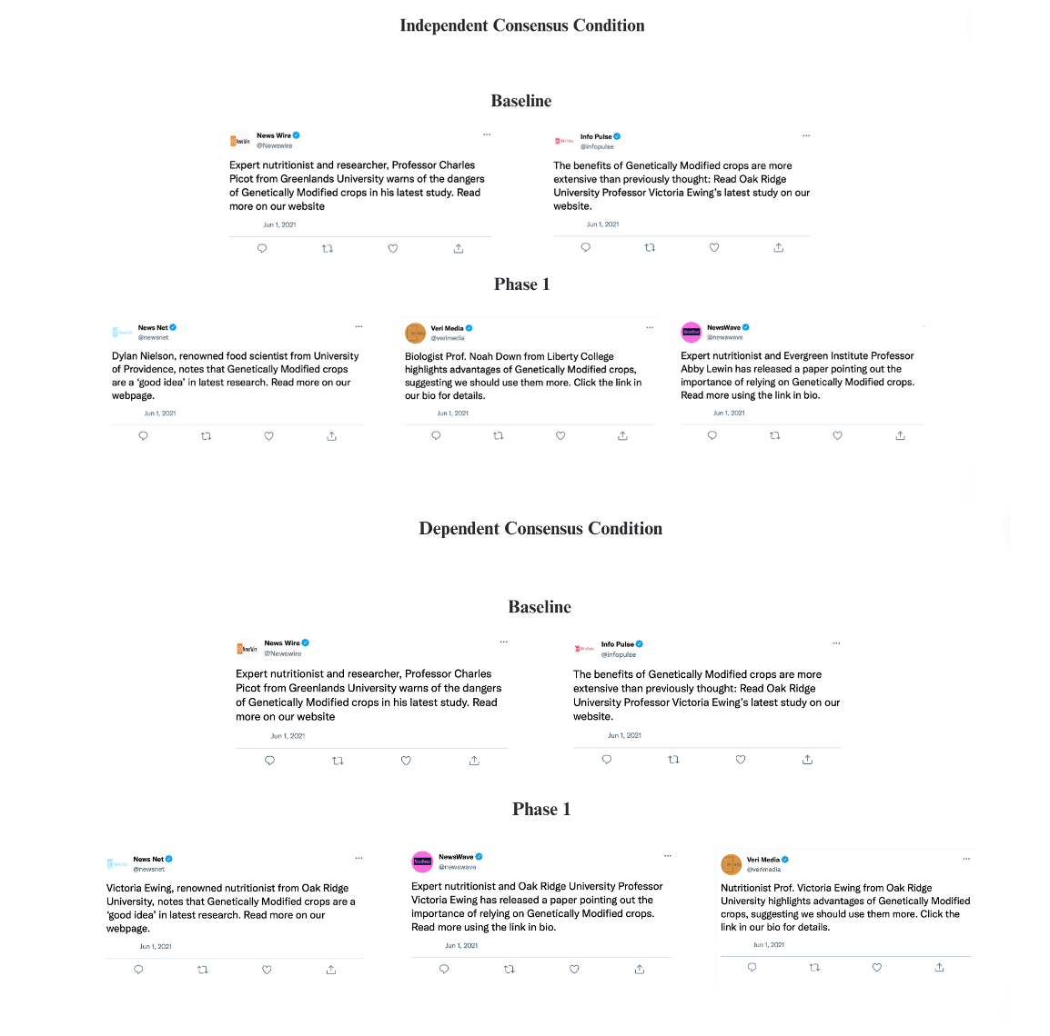
Example stimuli for Independent and Dependent consensus conditions across the first two phases of the experiment (baseline and phase 1)

Figure 2
Instructions for all participants
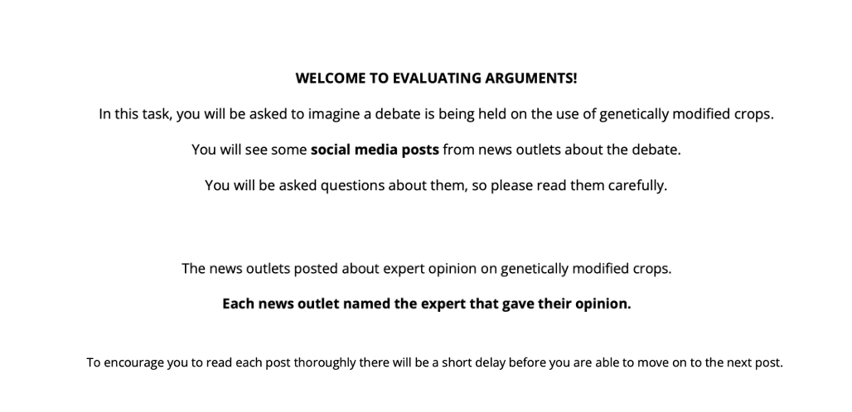
Note. Verbatim instructions seen by all participants prior to the social media task.

Procedure
The experiment was coded and run using JSPsych (de Leeuw, 2015). After providing consent and demographic information, each participant was shown the instructions outlined in Figure 2. Before proceeding to main task, participants had to achieve a perfect score on a three-item multiple-choice instruction comprehension test. Failure caused participants to loop back to the beginning of instructions.
The social media posts were then presented across four phases, as summarized in Table 1. In the phase 1 baseline, all participants were presented with two posts sequentially – one supporting and one opposing use of GM crops, with post order randomized. Participants had unlimited time to read each post, but could advance to the next screen 3 s after a post appeared. After reading both posts, participants rated their belief in the claims supporting GM crops: “Based on all the claims you have seen so far, to what extent do you agree that genetically modified crops are a good idea?”, using a 0-100 on screen slider (0 = Strongly disagree, 50 = Neutral, 100 = Strongly agree).
Table 1.
Number of positive (Pos) and negative (Neg) social media posts between and within subjects for baseline and phase dependent and independent consensus conditions.
 |  | Within subjects
 |  | Baseline Phase 1 |  | Phase 2 |  | Phase 3 |  | Phase 4
 |  | Pos | Neg | Pos | Neg | Pos | Neg | Pos | Neg
Between subjects | Dependent consensus | 1 | 1 | +3 | 0 | +3 | 0 | +3 | 0
 | Independent consensus | 1 | 1 | +3 | 0 | +3 | 0 | +3 | 0
 | TOTAL POSTS | 1 | 1 | 4 | 1 | 7 | 1 | 10 | 1

In each of the three subsequent phases, participants were shown three posts sequentially, all of which supported the use of GM crops. The presentation procedure for these posts was the same as in the baseline. After reading each set of three posts, participants re-rated their belief in the claim. Those in the independent consensus condition viewed a total of 9 social media posts across the four phases reporting that different experts supported the claim. For each post a different combination of expert name and academic institution was used, but a different media outlet was responsible for the post. Those in the dependent consensus condition viewed the same number of posts, all reporting that the same expert supported the claim. For each post the name of the expert and academic institution remained the same, but a different media outlet was responsible for the post. The particular expert/institution names used in the dependent condition, was randomly selected for each participant from nine possible combinations. In both conditions, the specific wording of each positive post varied slightly to promote authenticity. Previous work has shown that such paraphrasing of a claim can produce similar effects to verbatim repetition (Pillai & Fazio, 2024).
After phase 4, participants completed two checks of memory for post details. They were asked to estimate the total number of positive claims and total number of positive negative claims presented during the main task. They were then presented with a randomly ordered list of 14 expert names, containing the 11 names or 2 names used in the independent or dependent conditions respectively. They were asked to click on all those that actually were presented during the task.
Participants then completed three post-test questions. The first asked participants to rate their own view of GM foods prior to participation in the study ( ). Next, they were asked to type a free text response to a question about the effects of consensus on their belief in the claim. This was worded differently for the independent and dependent conditions “Most of the posts you saw cited [different] / [the same] experts. How did this influence your judgment about whether genetically modified crops are a bad idea?”. Finally, they were asked “How willing would you be to share one of the posts that had a positive view of genetically modified foods?”. Responses were made via a 0-100 on screen slider (0 =‘definitely not share’, 50 = ‘Neutral’, 100 = ‘Definitely would share).’
Exclusion criteria. Those in the independent consensus condition were excluded if they selected only one expert name in the memory check or if all of the names selected were incorrect. They were also excluded if the difference between their estimates of positive and negative claims was negative or zero. Those in the dependent condition were excluded if they selected more than two different expert names, or expert names that differed from those presented in the experiment. They were excluded if the difference between their estimates of positive and negative claims was negative.

Data analysis strategy
In order to quantify evidential support for and against the effects of interest, data were analysed using a Bayesian approach with default priors (Rouder et al., 2017). Analyses were carried out with the appropriate Bayesian packages in JASP v. 0.18.3 (JASP Team, 2024). We followed the conventions suggested by Lee and Wagenmakers (2014), that a Bayes Factor (BF₁₀ or BF₀₁) between 3 and 10 represents “moderate” evidence for the alternative (or null) hypotheses, a BF₁₀ between 10-30 represents “strong” evidence, a BF₁₀ between 30-100 represents “very strong evidence”, and a BF₁₀ above 100 represents “extreme evidence”. We report BF₁₀ when there is more support for the alternative than the null, and BF₀₁ when the evidence favors the null.

Results
Mean ratings of belief in the majority claim in each experimental phase are shown in Figure 3. Baseline ratings were made after viewing posts where there was no consensus view about the claim. Ratings in both groups were close to mid-point of the endorsement scale (independent: M = 49.831, 95% credible interval (CI) = 45.100 to 54.561; dependent: M = 49.925, 95% CI = 46.303 to 53.543). A Bayesian analysis of variance (BANOVA) of these baseline ratings found moderate evidence against a difference between baseline beliefs in the consensus conditions, BF₀₁ = 5.376.
Figure 3 shows that endorsements increased from the baseline to phase 2 in both consensus conditions. In subsequent phases, however, the pattern of ratings diverged, with further increases in endorsements in independent consensus, but no increases in dependent consensus. Ratings data were entered in a 2 (consensus type) x 4 (ratings phase) mixed model BANOVA with repeated measures on the second factor. We computed Bayes Factors comparing the likelihood of models that included each of the main effects of consensus type and ratings phase, and their two-way interaction, to equivalent models that omitted one of these effects. This analysis found extreme evidence of an increase in ratings over the four phases, BF₁₀ > 1000, and moderate evidence of an overall difference in ratings between consensus conditions, BF₁₀ = 3.497. Crucially, there was strong evidence of an interaction between ratings patterns and consensus, BF₁₀ = 10.922. Independent consensus became more persuasive as compared to dependent consensus as the size of consensus sample increased. A follow-up analysis found that moderate evidence in favour of the null when comparing belief in the claim based on independent or dependent consensus based on three sources, BF₀₁ = 4.808. This is notable because this consensus sample size is similar to that used in previous work which has demonstrated an illusion of consensus.
Participants were generally unwilling to share a post supporting GM food (independent: M = 30.662, 95% CI = 24.101 to 37.223; dependent: M = 30.701, 95% CI = 24.376 to 37.027). A univariate BANOVA found moderate evidence against a difference between consensus conditions in willingness to share, BF₀₁ = 5.376. There was moderate evidence against a difference between consensus conditions in prior beliefs about the value of GM foods (independent: M = 4.108, 95% CI = 3.741 to 4.474; dependent: M = 4.254, 95% CI = 3.927 to 4.581), BF₀₁ = 4.566.

Figure 3.
Experiment 1. Ratings of belief in the majority claim in each phase
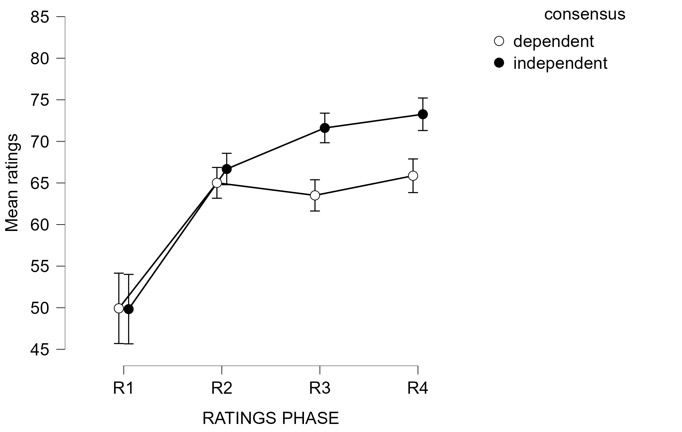
Note. Bars show 95% confidence intervals.

Experiment 2
Method
Participants
A total of 162 participants were recruited (Mage = 37.80 years, SDage = 14.60, females = 80, males = 82, non-binary = 0) and randomly allocated to either an independent or a dependent consensus condition. The majority (n = 150) were recruited and tested online via Prolific and received the same monetary payment as in the previous experiment. A minority (n = 12) were recruited from the UNSW undergraduate subject pool and received course credit for participation. Preliminary analyses found no differences between the ratings patterns of these subgroups, so they were combined in all subsequent analyses. Using the same criteria as Experiment 1, data from 16 participants was excluded (10 in the independent condition, 6 in the dependent condition) (final sample: independent consensus, n = 74; dependent consensus = 72). The study was pre-regsitered – see https://osf.io/2vnc6 for details.
Procedure
The experimental design and procedure were the same as Experiment 1 with the following exceptions. The most important change was in the valence of the majority of claims and ratings concerning GM foods. In this case, the majority of posts in both consensus conditions reported expert views opposing the use of GM crops. Accordingly, we modified the rating required in each phase, “Based on all the claims you have seen so far, to what extent do you agree that genetically modified crops are a bad idea?”. Likewise, in the post-test participants were asked “How willing would you be to share one of the posts that had a negative view of genetically modified foods?”.
The other minor change was that the question about prior views regarding GM foods was presented before the main task. We also added a rating of participants’ prior knowledge of GM foods (1 = ‘no knowledge’ 2 = ‘some knowledge’, 3 = ‘extensive knowledge).
Results
Mean ratings of endorsement of the majority claim in each experimental phase are shown in Figure 4. Baseline ratings were generally close to the mid-point of the scale, although compared to Experiment 1, participants were slightly more likely to endorse the (negative) claim at baseline (independent: M = 55.338, 95% CI = 50.276 to 60.400; dependent: M = 55.583, 95% CI = 51.541 to 59.625). There was moderate evidence against a difference between baseline ratings in the consensus conditions, BF₀₁ = 5.618.
The Figure shows that the pattern of change in subsequent ratings was generally similar to that observed previously. A 2 (consensus type) x 4 (ratings phase) mixed model BANOVA found extreme evidence of an increase in ratings over the four phases, BF₁₀ > 1000, strong evidence of an overall difference in ratings between consensus conditions, BF₁₀ = 16.186, and very strong evidence of an interaction between ratings patterns and consensus, BF₁₀ = 50.751. We again found that independent consensus became increasingly more persuasive than dependent consensus as the size of the sample on which the consensus was based increased. In this case, there was inconclusive evidence for the null when comparing belief in the claim based on independent or dependent consensus based on three sources, BF₀₁ = 2.90.
Figure 4
Experiment 1. Ratings of belief in the majority claim in each phase
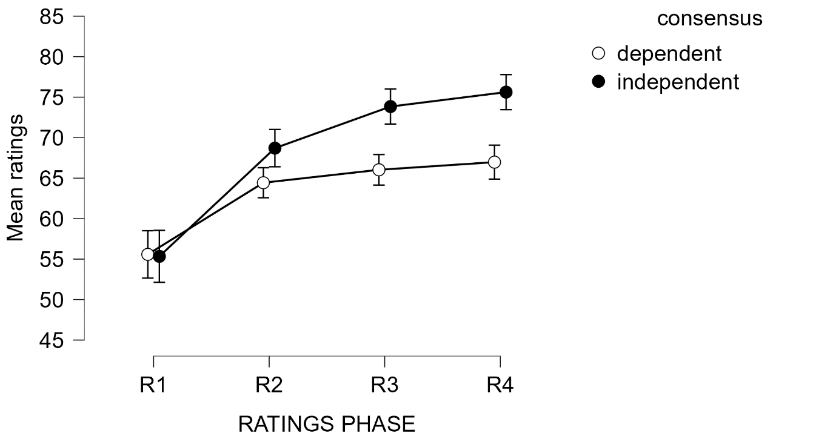
Note. Bars show 95% confidence intervals.

Unlike the previous study, in this experiment we did find moderate evidence for a difference between consensus conditions in willingness to share a post, with those in the independent consensus condition more likely to share (independent: M = 48.730, 95% CI = 41.304 to 56.156; dependent: M = 35.472, 95% CI = 28.275 to 42.67), BF₁₀ = 3.405. In this study, there was inconclusive evidence of a difference between consensus conditions in prior beliefs about the value of GM foods (independent: M = 3.716, 95% CI = 3.36 to 4.073; dependent: M = 4.083, 95% CI = 3.766 to 4.401), BF₀₁ = 1.931. When prior beliefs were entered as a covariate into the factorial BANOVA on endorsement ratings, there was extreme evidence of a positive relationship between prior beliefs and ratings, BF₁₀ > 1000. However, the qualitative pattern of results did not change with evidence for the alternative hypothesis found for both main effects and the interaction (ratings main effect: BF₁₀ > 1000; consensus main effect: BF₁₀ = 8.588; ratings x consensus interaction, BF₁₀ = 34.487. A Bayesian contingency test found moderate evidence of no relationship between categorical ratings of participant prior knowledge about GM foods and consensus condition (independent: no knowledge = 26.667%, some/extensive knowledge = 73.333%; dependent: no knowledge = 22.667%, some/extensive knowledge = 77.333%), BF₀₁ Independent multinomial = 4.901.

Incomplete References
Alister, M., Ransom, K. J., Connor Desai, S., Soh, E. V., Hayes, B., & Perfors, A. (2024). How convincing is a crowd? Quantifying the persuasiveness of a consensus for different individuals and types of claims
Bovens, L., & Hartmann, S. (2003). Solving the riddle of coherence. Mind, 112(448), 601-633.
Connor Desai, S., Xie, B., & Hayes, B. K. (2022). Getting to the source of the illusion of consensus. Cognition, 223, 105023.
Ernst, N., Kühne, R., & Wirth, W. (2017). Effects of message repetition and negativity on credibility judgments and political attitudes. International Journal of Communication, 11, 21.
Fazio, L. K., Pillai, R. M., & Patel, D. (2022). The effects of repetition on belief in naturalistic settings. Journal of Experimental Psychology: General.
Hassan, A., & Barber, S. J. (2021). The effects of repetition frequency on the illusory truth effect. Cognitive research: principles and implications, 6(1), 38.
Oktar, K., Lombrozo, T., & Griffiths, T. L. (2024). Learning From Aggregated Opinion. Psychological Science, 09567976241251741.
Pillai, R. M., & Fazio, L. K. (2024). Repeated by many versus repeated by one: Examining the role of social consensus in the relationship between repetition and belief. Journal of Applied Research in Memory and Cognition.
Whalen, A., Griffiths, T. L., & Buchsbaum, D. (2018). Sensitivity to shared information in social learning. Cognitive Science, 42(1), 168-187. https://doi.org/10.1111/cogs.12485
Yousif, S. R., Aboody, R., & Keil, F. C. (2019). The illusion of consensus: A failure to distinguish between true and false consensus. Psychological Science, 30(8), 1195-1204.

In the dependent condition, a zero difference between estimates of positive and negative posts is acceptable. It implies that the participant was responding to the number of independent expert posts that they viewed (one pro, one con).

